Guide to Criteria used when judging photographs

Introduction
What makes a "good photo" is something ultimately subjective. However, there are some very useful guidelines that have been formulated by master photographers over more than 150 years of photography. They can help you determine what a ‘good’ photo is. Please study them with care and use them to enhance your own photographs. These guidelines represent the distilled wisdom of generations of photographers.

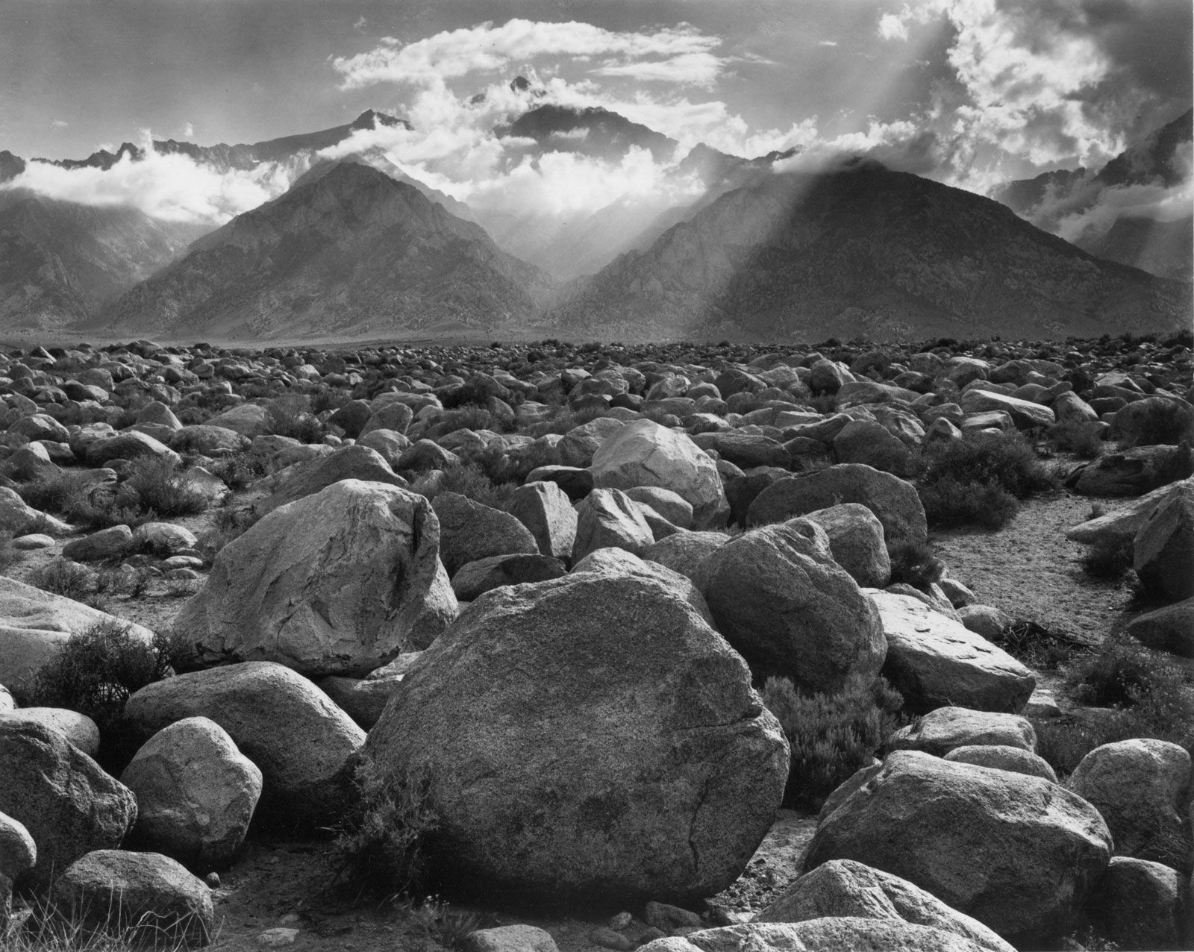 Ansel Adams (Clearing Storm)

1. Is there a clear centre of interest? In a strong photo, the viewer can immediately identify the subject. While this may sound obvious, a surprisingly high number of photos fail to clearly identify the main subject. Instead, a complex montage of elements competes for the viewer's attention. In other words, the image is messy with no obvious focus of interest.

In a strong photo, the subject should dominate the image and form the viewer's first impression. If the subject is strong, the viewer's eyes may move to explore other areas of the image, but the eyes are drawn inevitably back to the subject.

To evaluate your own photos for a strong centre of interest, try asking yourself these questions. Or, show the picture to a friend and ask your friend to honestly answer the questions.
- When you look at the photo, what is the first thing you see?
- If you're evaluating your own image, is what you see first the subject you had in mind for the photograph?
- What holds your eye the longest?
- Do other elements in the image compete with the subject for attention?
- Do technical aspects such as light and the direction of light, depth of field, focus, and so on add to or detract from the subject?

2. Is the image composed well? In a strong photo, there should be a sense of overall organization. While entire books are written on composition, at the most basic level, composition is the process of establishing a sense of order for the elements within an image. Note: composition rules or guidelines are a helpful starting point, but they are useful only as long as they enhance the overall image.

As a quick review, here are a few basic composition pointers.

Fill the frame. Filling the frame helps establish the centre of interest, and, simultaneously, it helps exclude competing background details. You can fill the frame by moving closer to the subject or by using a longer focal length (or zooming in). This simple guideline is one of the most important lessons we have to learn. Due to the way our vision works, it is all too easy to neglect the surroundings as we concentrate on our centre of interest. Consequently, when we inspect the resulting photo the centre of interest may have lost its significance as it competes with its surroundings.


Lewis Hine

Organize elements. In composition, the ‘Rule of Thirds’ is often used to organize elements in a composition. This rule is derived from the ‘Golden Section’ or ‘Golden Rectangle’ that divides a space, such as a photographic frame, into equal segments to create pleasing proportions. In simple terms, if you apply the Rule of Thirds in photography you simply imagine a ‘noughts and crosses’ pattern on the viewfinder. Then, when you place the subject of the photo at one of the intersection points, the result is a pleasing sense of order. Note: some cameras allow you to display this grid on the LCD or in the viewfinder.

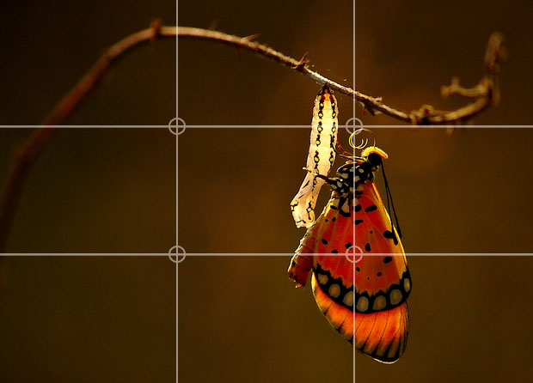

Control the background. A non-distracting background is a compositional tool to help bring attention to the subject of the photo. You can control the background by moving your position or moving the subject to avoid background distractions and by using a wider aperture (smaller f-stop) to blur the background. It's a good practice to review the entire scene and, when possible, eliminate or rearrange as many distracting background elements as possible (see “Fill the frame” above).

Keep it simple. The fewer the elements in a photo, the stronger the statement the image makes. Simplicity also helps prevent the viewer's eye from being distracted.
To evaluate the composition of your images, try asking these questions:
- Is there a sense of order and balance in the image that helps lead the eye through the composition?
- Are elements included that do not contribute to the subject of the image?
- Are elements excluded that, if included, would have enhanced the subject of the image?
- Do the depth of field, focal length (lens or zoom setting), lighting, angle, and perspective enhance the composition?
- Does the crop enhance the composition?

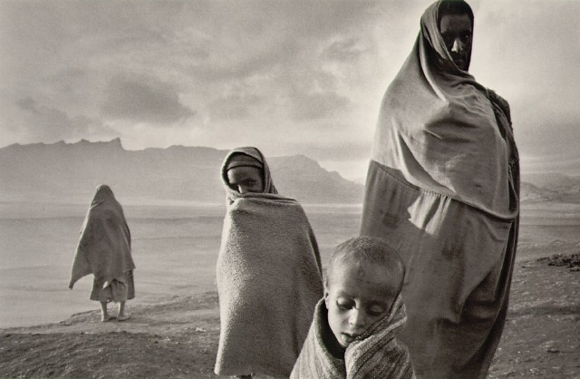
Sabastião Salgado

3. Is the focus crisp and is the exposure appropriate? With the exception of photos that either intentionally show motion or are taken as soft-focus images (such as a portrait), tack-sharp focus is one of the first things that everyone notices first about an image. Going a step further, the centre of focus should be on the centre of interest of the subject. The sharpest point of the picture should pinpoint what the photographer sees as the most important aspect of the image (e.g., the eyes in a portrait).

Steve McCurry

The exposure (the combination of focal length [lens or zoom setting], aperture, shutter speed, and ISO) should also enhance the intent of the photo.

Questions that can help you evaluate whether focus and exposure settings are appropriate for an image include:
- Is the sharpest point in the image on the centre of interest of the subject of the photo?
- Does the depth of field enhance the subject, mood, or look of the image or does it distract from it?
- Does the focal length or zoom setting enhance the subject and message?
- Does the image have good overall contrast for the type of image the photographer intended?
- Does the colour appear natural and/or does it help set the mood of the image?
- If the image is in colour, would it be stronger in black and white, or vice versa?
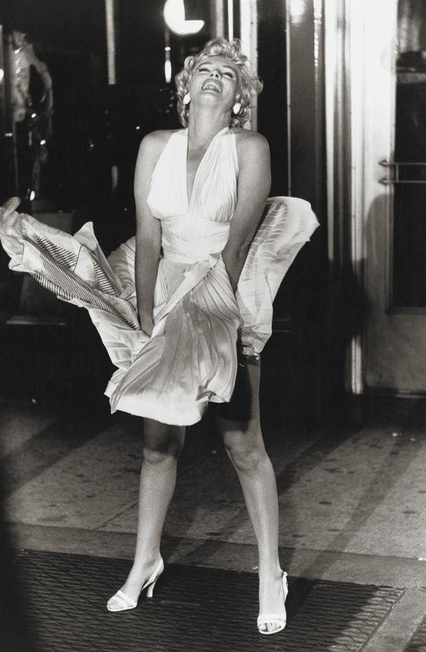
Garry Winogrand

4. Does the photo tell a story? Most often, the difference between a photo you remember and one that you quickly forget depends on whether the photo tells a story.
In strong photos, the story is revealed at first glance, and it is self-contained. In the best images, the story evokes an emotional response from the viewer. I believe it's that emotional response that ultimately makes the image memorable.

Try asking these questions as you evaluate images to decide if the image tells a story.
- At a minimum, does the photo make a statement that you can articulate?
- Does the photo elicit an emotion? In other words, can you relate to the subject or the situation?
- What could be changed in the image to give it a stronger story or message?

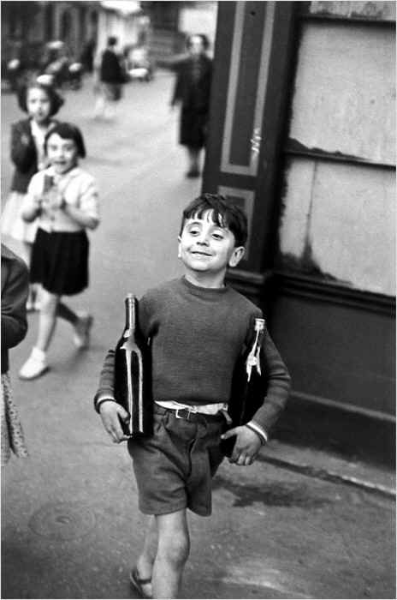
Cartier-Bresson

5. Does the lighting enhance the subject and message? Like the composition, lighting is a subject that is worthy of book-length discussions. Whether in shooting or evaluating photos, light should be used to its maximum potential to reveal what's important in the image and to set the overall tone of the photo.

In masterful hands, lighting is used selectively to focus attention on specific areas of the subject while simultaneously de-emphasizing less important areas; to guide leading the eye through the composition, and to establish the overall mood and tone of the image by taking advantage of the different temperatures (colours) of light.
Light is another "design tool" that can be used to enhance the overall mood and intent of the image and subject. And, of course, there are few photographers who fail to take advantage of the superb colours of light during sunrises and sunsets.

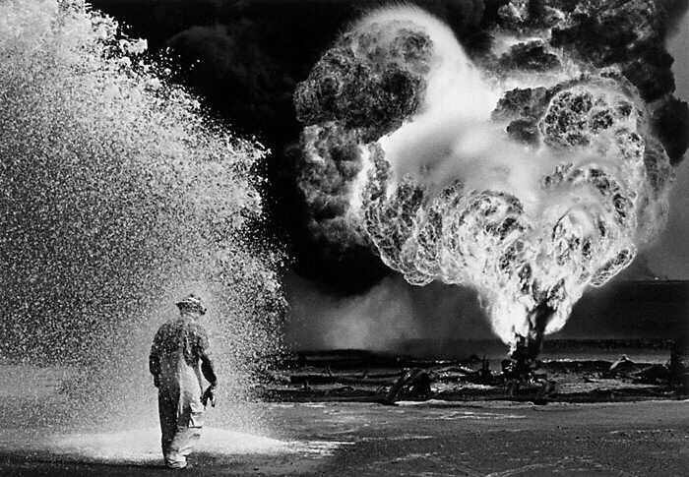
Sabastião Salgado

It is tempting to photograph a scene at the time we just happen to be there, rather than returning to the same place at a time when the lighting would enhance the type of image we wish to create. This is often the difference between a mediocre photo and a great one.

When evaluating the lighting merits of a photo, ask:
- Is the intensity and colour of light appropriate for the subject?
- Is the light too harsh, too contrasty, or is it too soft and too flat?
- Are all important aspects of the subject well lit, or could the lighting be improved by using a flash, fill flash, reflector, or auxiliary light?
- Does the light help convey the overall message of the photo?
- In a colour photo, is the colour balanced or corrected for the light temperature (in other words, the overall colour should be natural-looking). And if it isn't, does the colour cast contribute to the photo?

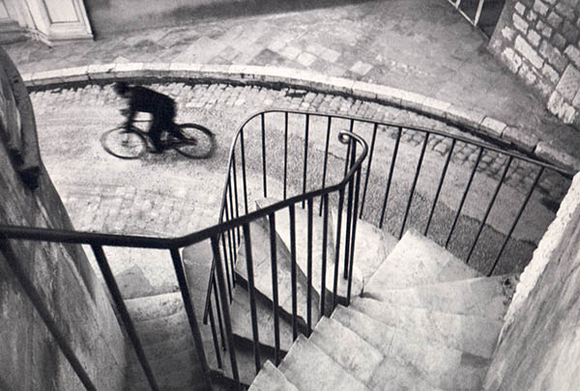Cartier-Bresson

6. Is the approach creative? In broad terms, we define "creative" as an image that goes beyond predictable techniques and treatments. In more specific terms, the best creative images show subjects through the photographers' eyes and perspective. In other words, the photographer reveals the subject in extraordinary ways: ways that the viewer otherwise would not have seen.

Creative techniques and subjects can range from bringing abstract ideas into a visual form, taking a concrete idea and making it abstract, relating or associating unrelated concepts into a visual space, or, in short, taking a fresh look at and lending the photographer's unique thinking and vision on a subject.
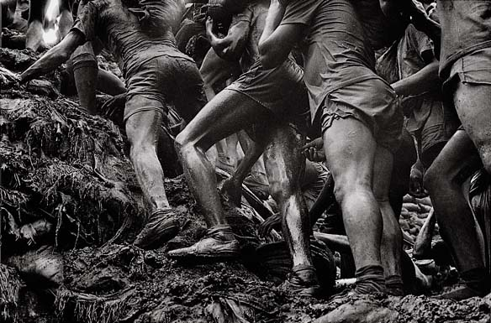 Sabastião Salgado

When evaluating the creativity of a photo, ask yourself:
- Does the photo disclose more about the subject, or show it in unexpected ways?
- Does the photo relate visual elements in unusual and intriguing ways?
- Is the photo interesting and fresh, or is it just too weird for words?
- Does the photo raise questions – perhaps ambiguous or unanswerable − that create mysteries, doubts, or uncertainties? In other words, does it expand our vision and our thoughts; extend our horizons; evoke awe, wonder, amusement, compassion, horror, or any of a thousand responses?


Sabastião Salgado

